--1. This query returns the patron names (desc order) along with the no. of times they have failed to return a resource on time between 5th oct and 5th nov

select count(r.res_id), p.name

from reservation r, patron p

where r.due_date >= '05-OCT-2015'

and r.due_date <= '05-NOV-2015'

and r.resc_type <> 'Room'

and r.patron_id = p.patron_id

and ((r.isactive = 1 and r.due_date < sysdate) or (r.isactive = 0 and r.checkin_date > r.due_date))

group by p.patron_id, p.name

order by p.name desc;

--We are taking all those reservations in consideration for which either the resource is not returned till date or for which the resource was returned after due date.

Output:

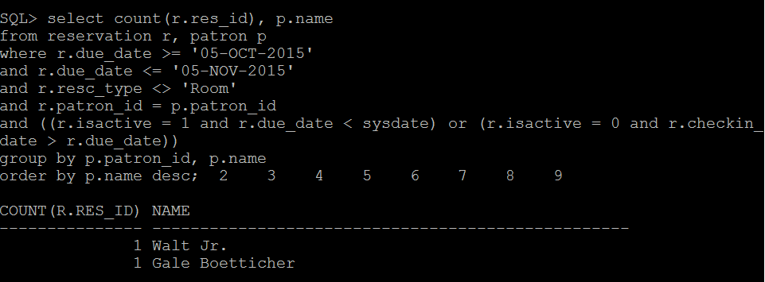

--2. This gives the count of all rooms which were rendered null and void because the patron did not checkout.

select count(*)

from resv_room r

where r.is_active = 0

and r.start_time >= '30-OCT-2015'

and r.start_time <= '06-NOV-2015';

-- Below is the description of how our table "resv_room" stores the data

-- is_active = 0 : null void ; is_active = 1: active reservation waiting for checkout ; is_active = 2: checked out

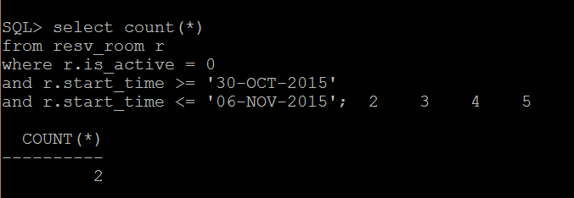

--3. This gives the sum of the late fee that was actually collected by the library between 5th oct and 5th Nov

select sum(late_fee)

from CalcLateFee cl, reservation rsv

where cl.status = 1

and cl.res_id = rsv.res_id

and rsv.checkin_date >= '05-OCT-2015'

and rsv.checkin_date <= '05-NOV-2015';

-- Entries get inserted in our "calclatefee" table only if the resource has been returned after the due date. The status column checks if the late fee was paid or unpaid.

Output:

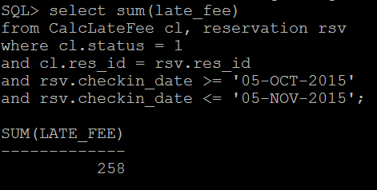

--4. This gives the capacity of the room which is maximum in demand based on the reservations made between 5th oct and 5th nov

select temp.rm

from (select r.capacity rm, count(*) ct

from resv_room rsv, room r

where rsv.room_no = r.room_no

and rsv.start_time >= '05-OCT-2015'

and rsv.start_time <= '05-NOV-2015'

group by r.capacity ) temp

where temp.ct = (select max(temp1.ct) from (select r.capacity rm, count(*) ct

from resv_room rsv, room r

where rsv.room_no = r.room_no

and rsv.start_time >= '05-OCT-2015'

and rsv.start_time <= '05-NOV-2015'

group by r.capacity) temp1) ;

-- room table has a list of all rooms in the library, resv_table has a list of all requests made to reserve any room.

